**SYUHADA ATHIRAH BINTI MOHD ZAMZURI**

**CI230116**

**SECTION 7**

**Lab activity 7**

**Output:**

**Register Form**

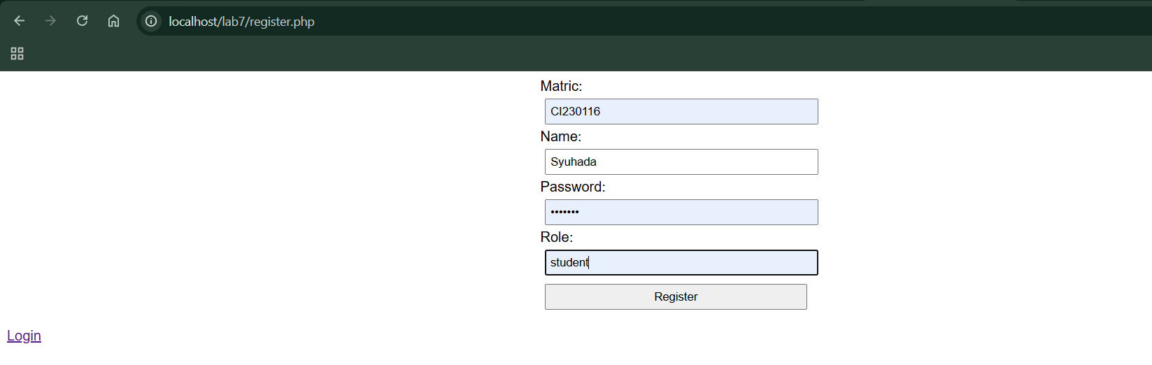

**Login Form**

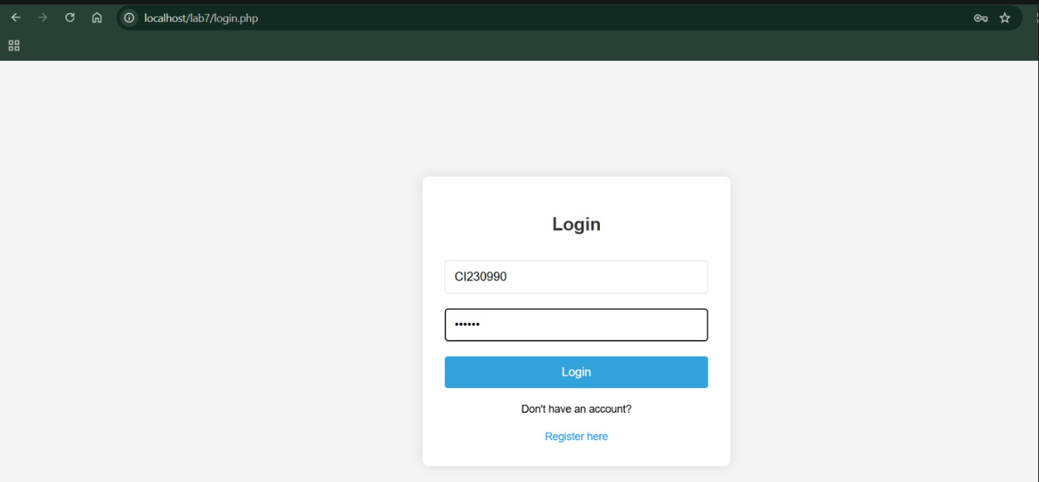

**User List**

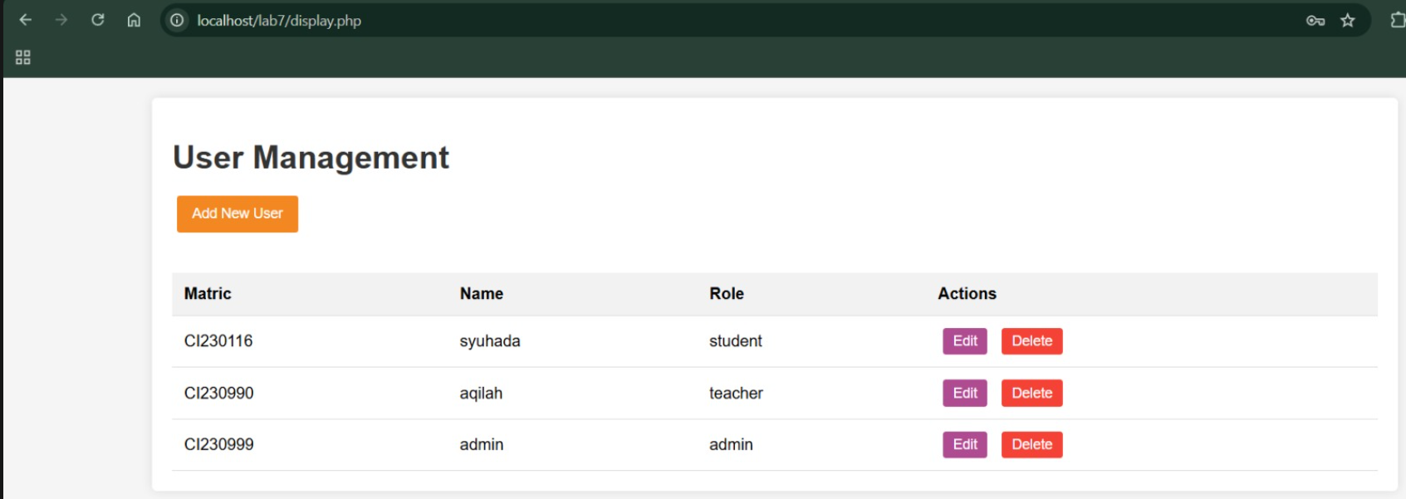

**Reflective journal:**

This lab on CRUD operations with PHP significantly deepened my understanding of backend development. I successfully built a user management system that includes secure registration, login functionality, and administrative controls. One of the most challenging aspects was implementing proper security measures particularly password hashing and protecting against SQL injection. Leveraging PDO and prepared statements proved essential in addressing these concerns.

I also gained a stronger appreciation for session management and its role in restricting access to authenticated users. While the system functions as intended, I recognize opportunities for improvement, such as integrating AJAX for smoother, real-time updates and enhancing error handling for a better user experience.

Overall, this lab not only strengthened my PHP skills but also underscored the importance of robust data validation and security in web development. In future iterations, I’m eager to explore more advanced features like role-based permissions to enable more dynamic and flexible access control.

**Summary:**

In this lab project, I developed a comprehensive user management system using PHP and MySQL. The system includes a structured database with a users table and supports full CRUD (Create, Read, Update, Delete) operations for managing user records. I implemented secure user registration and login functionality, incorporating password hashing to protect user credentials. Session management was used to restrict access to authenticated users and enforce role-based access control. Additionally, I applied CSS styling to enhance the user interface and improve overall usability.